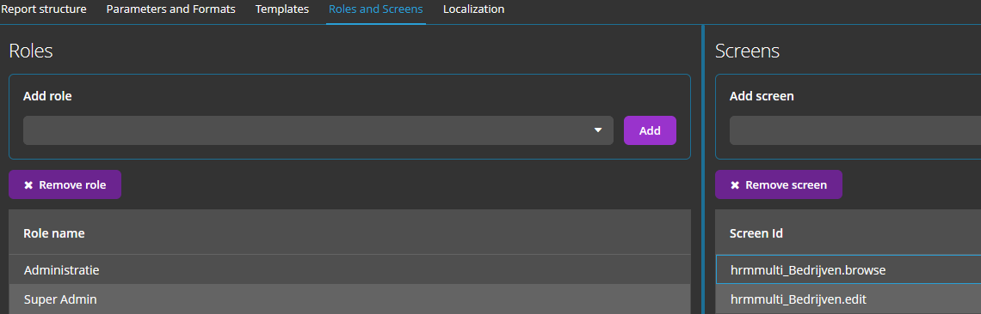

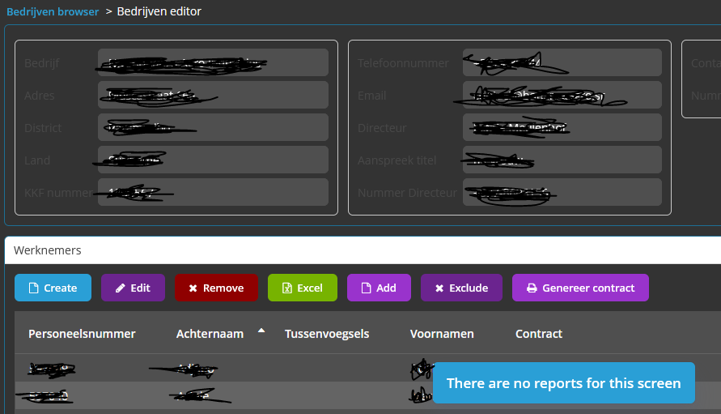

@Inject  
**private** Button **reportButton**;  
  
@Subscribe  
**protected void** onInit(InitEvent event) {  
 **reportButton**.setAction(**new** EditorPrintFormAction(**this**, **null**));  
}